Homework #5

1a.
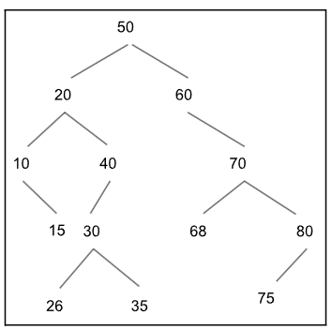

1b.
inorder traversal: 10 15 20 26 30 35 40 50 60 68 70 75 80
preorder traversal: 50 20 10 15 40 30 26 35 60 70 68 80 75
postorder traversal: 15 10 26 35 30 40 20 68 75 80 70 60 50

1c.
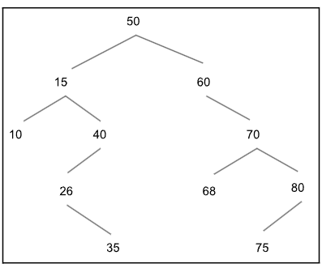

1a.
struct Node
{
int data;
Node* parent;
Node* rightChild;
Node* leftChild;
};

2b.
//based on the lecture example
//uses recursion
//to insert to the tree, follow the tree path going left if nodeData is less than the root node or right if nodeData is greater than the root node

void insertAux(Node*& node, Node* parentNode, int nodeData)
{
if (node == nullptr) //perform insertion if you have come to a leaf node
make n point a new Node object with the data members: data = nodeData,
leftChild = nullptr, rightChild = nullptr, parent = parentNode
else if (nodeData < n->data) //go left if < than current node
insertAux(node->left, node, nodeData)
else //go right if > than current node
insertAux(node->right, node, nodeData)
}

//call the auxiliary function created above
//pass in a pointer to the root Node of the tree
void insert(Node*& rootNode, int nodeData)
{
insertAux(rootNode, nullptr, nodeData); //root has no parent so pass in nullptr
}

3a.
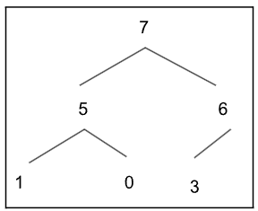

3b. 7 5 6 1 0 3

3c. 6 5 3 1 0

4
a) O(C+S)
vector<pair<string, list<int>>> Outer vector is unsorted and there are C items. The inner list is sorted and there are S items. We would do a linear search (b/c unsorted) to find the class (O(C)). The list is a linked list and thus we can’t do a binary search. So when we search for the student, we do another linear search that takes O(S). Remember that a binary search on a linked list would not take logS time because you have to go form node to node to get to the middle of the list. This would be O(S)/linear time anyways.

b) O((logC) + S)
map<string, list<int>> Nothing is sorted. To find the class within the map you would look through the binary search tree that the map uses. This takes O(log C) time. Next, you would do a linear search through the list which takes O(S) operations.

c) O(log C + log S)
map<string, set<int>> The map and set use a BST. Searching through the map’s BST for a specific class would take log C time. Searching through the set’s BST for a specific student would take S time.

d) O(log S)
unordered_map<string, set<int>>. The unordered map uses a hash table and the set uses a BST. Searching for a class in the unordered map would take O(1) operations. Searching in the binary tree for a specific student would take O(log S) operations. O(1) is constant so we nix it.

e) O(1)
unordered_map<string, unordered_set<int>>. Two hash tables are used. It takes O(1) to search for the specific class. It takes O(1) to search for the specific student.

f) O((log C) + S)
map<string, set<int>> Map uses a binary tree, so it will take O(log C) operations. Then, we will have to visit every item in the set which will take O(S) operations.

g) O(S log S)
unordered_map<string, unordered_set<int>> The unordered_map uses a hash table. Finding a specific class will take constant time (O(1)). The unordered_set uses a hash table. The items will not be in order across the buckets. The details of the hash function are unknown. We have to sort them. Storing them in a vector means it will take O(S) to get them in and out. Sorting would take S log S operations if we were to use merge sort.

h) O(C log S)
unordered_map<string, set<int>> We will go through all C classes and check whether the student is in them. Unordered map uses a hash table. Going through each class will take O(C) operations. The set uses a binary search tree. Searching for a specific student takes O(log S) operations.

